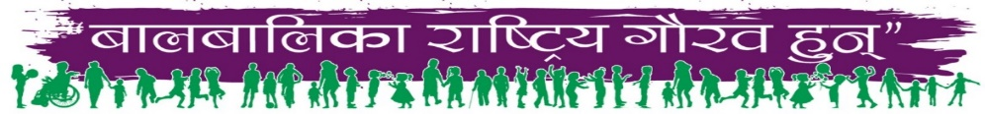

“Just World for Children”
Call to Action from the Global Assembly on Child Rights
2024

Background

In the year 2000, amidst widespread protests against the consequences of neo-liberal globalization, a critical need arose within various social spheres including movements, unions, academia, and more. It became essential to engage in discussions about alternatives to neo-liberal development. As the World Economic Forum gathered in Davos, Switzerland to bolster neoliberal globalization in favor of capitalist interests, a counter-hegemonic movement began to take shape. It was against this backdrop that the inaugural World Social Forum (WSF) convened in Porto Alegre, Brazil, offering an open arena for the exchange of ideas, experiences, and strategies. The objective was clear: to cultivate alternatives and organize resistance against the forces driving neo-liberal globalization, climate injustice, patriarchy, castism, racism, and war. Unified under the rallying cry of 'Another World is Possible', the WSF emerged as a unifying force, providing a platform for democratic deliberation, proposal formulation, and coalition building.

During the World Social Forum 2024 (WSF2024) held in Nepal from February 15-19, the tradition of providing a platform for diverse voices persisted, including social movements, laborers, farmers, civil society groups, and marginalized communities, under the theme "Another World is Possible." Central to WSF2024 were the youths (adolescents) who led the Global Assembly on Child Rights, echoing the theme "Just World for Children." Additionally, several parallel sessions covered various critical topics, including the Marginalization of Children and Youth Mental Health, Discrimination against Dalit Children and the Way Forward, Global Panel on Child Labor, Universalizing Childcare Services, Interaction on Education for Children Living in Poverty, Dialogue on the Right to Education and Climate Justice, Youth-led Efforts to Dismantle Child, Early, Forced Marriage, and Union (CEFMU), and Safer Internet Day - Protection of Children in the Digital Age. These discussions, alongside sessions on Violence against Children, informed the subsequent call to action.

- As the cornerstone of our humanity, we demand unequivocally that children be recognized as the Global Pride on an international scale and as National Pride within each nation. Adequate investments must be made to uphold their fundamental rights, including the right to survival, the right to protection, the right to development, and the right to participation.
- We demand urgent action to address widening economic disparities exacerbated by neo-liberalism and worsened by COVID-19, pushing millions into poverty. Governments must recognize the role of economic inequality in perpetuating social injustices, especially among vulnerable children. Through prioritizing measures promoting economic equity, including investments in education, healthcare, and social support systems, we demand the creation of a more resilient and just society that safeguards the well-being and future of all children.
- We demand urgent action on climate justice for children, especially the marginalized, as they are disproportionately affected by climate change. Governments must prioritize policies protecting children's rights, mitigating environmental harm, and ensuring equitable access to resources. Empowering marginalized children with resilient education, healthcare, and social support systems is crucial. Investments in renewable energy and sustainable infrastructure are necessary to mitigate climate change's impact. Let's unite to safeguard all children's future and foster a just and sustainable world.
- We demand urgent action to dismantle the caste-based discrimination existing in many countries, particularly against Dalits, perpetuating systemic marginalization and exclusion. Governments must prioritize the formulation and implementation of policies empowering Dalit communities, and ensuring access to education, healthcare, and social services. Let us unite in our demand to eradicate caste-based discrimination, creating a world where every child can realize their full potential.
- We hereby strongly urge immediate action to prioritize children's education on a global scale. Access to free quality education is a fundamental right, yet millions of children worldwide remain deprived. It is imperative that governments ensure universal access, invest substantially in infrastructure and resources, dismantle existing barriers, promote inclusive learning environments, empower children as active participants, and foster lifelong learning opportunities. We condemn the privatization of education and strongly demand that at least 20 percent of the national annual budget be invested in public education.
- We demand urgent action to end global child labor and protect children from exploitation. Millions suffer hazardous work, losing childhood, education, and rights. Governments must enforce strict laws, enhance inspections, and support impoverished families. We must unite to break this cycle, ensuring every child grows in safety, free from labor.
- We demand urgent global action to end child marriage. It robs vulnerable children (especially girls) of childhood, education, and opportunities. Governments must enforce laws against underage marriage, promote girls' education and empowerment, and provide support to at-risk families. Addressing root causes like poverty and gender inequality is crucial. Let's unite to protect children from this harmful practice, ensuring every child can fulfill their potential. We demand immediate action against Gender-Based Violence (GBV) and Harmful Traditional Practices (HTP) to safeguard children.
- We demand urgent action to protect the rights of children from marginalized communities, especially children living with disabilities, street-connected children, and children from LGBTIQ communities. This includes addressing issues such as Sexual and Reproductive Health and Rights (SRHR) to ensure equitable access to healthcare and support services for all children, regardless of their background or identity.
- We demand urgent and effective action to end violence against children and combat trafficking. Governments must enforce laws, hold perpetrators accountable, and provide support to affected communities. We further demand investment in protection mechanisms in the local, national, and global level.
- We demand immediate action to ensure meaningful participation of children at all levels, expanding their civic space. Governments must guarantee children's rights to freely associate, express opinions, participate in decision-making, and engage in civic activities. Establishing child-friendly local governance and robust social protection mechanisms is crucial to safeguard children's rights and well-being within communities.

Let's prioritize empowering children to shape their futures and contribute to the betterment of society through their active involvement in decision-making processes.
- We demand urgent action to tackle the mental health crisis affecting children and adolescents, worsened by significant underfunding of mental health services. Countless young individuals lack essential mental health support, perpetuating suffering and stigma. Governments must prioritize mental health funding, expanding access to quality care, including counseling and therapy.
- We demand urgent action on digital safety, including combating Sexual Exploitation of Children online. Inadequate measures expose kids to cyberbullying, harmful content, and exploitation. Governments must prioritize cybersecurity, invest in education, and enforce online privacy regulations. Collaborations with tech firms and civil society are essential for innovative solutions and fostering responsible digital citizenship.
- We demand urgent action to uphold the principle of “Children as Zones of Peace” and halt the tragic killing of innocent children in conflict zones and wars worldwide especially in Gaza. Despite international agreements and conventions, children continue to suffer the brutal consequences of armed conflicts, facing violence, displacement, and loss of life. It is the solemn duty of the international community to prioritize the protection of children in conflict zones by vigorously enforcing existing laws, holding perpetrators of violence against children accountable, and providing humanitarian assistance to affected communities. Diplomatic efforts must be intensified to resolve conflicts peacefully and ensure the safety and well-being of children.
Let us stand united in our unwavering commitment to end the senseless killing of children in conflict and create a world where every child can grow up in peace and security.
By recognizing children as indispensable agents of change and addressing pressing global challenges such as climate change, child labor, child marriage, mental health, trafficking, sexual abuse, digital safety, and conflicts, it has woven a unified call to action. Let us heed this call and work tirelessly to ensure that every child can thrive in a world that is just, equitable, and safe. Together, let us build a future where the rights and well-being of all
children are upheld and protected, ending structural disparities and dismantling digital hegemony.
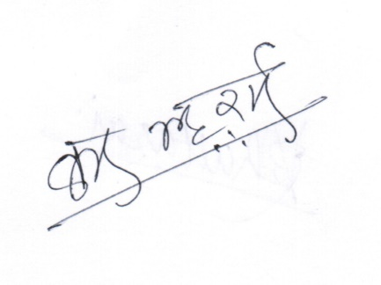

Kumar Bhattarai
Spokesperson

